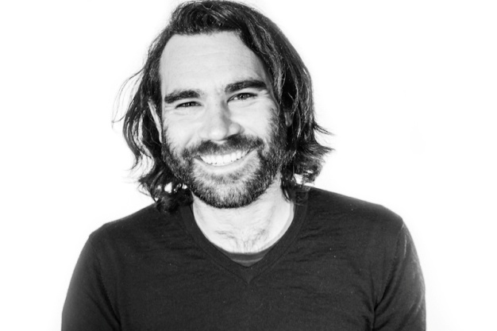
THE DAY JOB
SAM WHEAT PRODUCER - ENGINEER - MIXER
As chief engineer at Metropolis Studios for the past 6 years, Sam has worked with numerous platinum selling top ten and number one artists, and has also led a revival in the Live to Vinyl recording technique, where the artist is mixed and mastered live as they are being recorded straight to acetate.
His most recent credits include John Legend, Paloma Faith, Mika, Benjamin Clementine, George Clinton, Nitin Sawhney, Van Morrison, Public Service Broadcasting and Pharrell Williams.
Artist Title Label Credit Year

Knaves Nebula Knaves Producer 2015
We Were Evergreen Once I Had Because Music Producer 2015
The Council The Council EP Empire Productions Engineer 2015
David Guetta ft Emeli Sande What I Did For Love Parlophone Engineer 2015
Wishbone Ash Metropolis Live sessions Talking Elephant Engineer/Mix 2015
Public Enemy Metropolis Live sessions Universal Engineer/Mix 2015
Public Service Broadcasting The Race For Space Love Da Records Engineer 2015
Kelis Metropolis Live sessions Ninja Tunes Engineer/Mix 2015
Mika No Place In Heaven Universal Engineer 2015
Namie Amuro _genic Dimension Point Japan Engineer 2015
George Clinton Metropolis live sessions Universal Engineer/Mix 2015
The Rolling Stones LA Forum (Live 1975) Eagle Vision / Universal Engineer/Mix 2014
Ellie Goulding Live to Vinyl session Seat On Track Engineer/Mix 2014
The Horrors Live to Vinyl session Seat On Track Engineer/Mix 2014
Bombay Bicycle Club Live to Vinyl session Seat On Track Engineer/Mix 2014
The Bees Live to Vinyl session Seat On Track Engineer/Mix 2014
David Guetta Listen What A / Parlophone Engineer 2014
ZZ Top Live at Montreaux 2013 Eagle Vision Engineer/Mix 2014

Rita Ora How We Do (Party) Roc Nation / Columbia Engineer 2013

Heaven 17 Metropolis Live sessions Edsel Records Engineer 2013
Belinda Carlisle Metropolis Live sessions Edsel Records Engineer 2013

The Joy Formidable Wolf’s Law Atlantic Engineer 2013

Paloma Faith Fall To Grace RCA Engineer 2012
Little Mix DNA Syco / Sony Engineer 2012

Caravan Metropolis Live sessions Salvo Engineer 2012

Kate Miller-Heidke Nightflight Sony Australia Engineer 2012
Rita Ora ORA Roc Nation / Columbia Engineer 2012
Leona Lewis Glassheart Syco / Sony Engineer 2012

Cheryl A Million Lights Polydor Engineer 2012
The Fall Ersatz GB MVD Audio Engineer 2011

Amy Winehouse Lioness: Hidden Treasures Island Engineer 2011
Claire Maguire Light After Dark Polydor Engineer 2011
Katherine Jenkins A Flower Tells A Story Warners Engineer 2011
Swedish House Mafia Miami 2 Ibiza Virgin Engineer 2010
Claire Tchaikowski Those Thousand Seas Grá Mór Phonic Recs Engineer 2010
Foals Metropolis Live sessions Warner / Transgressive Engineer 2010
They Came From the Stars.. We are all in the Gutter.. Thisisnotanexit Engineer 2008
The Humanity Bass Linear Happy Engineer 2008
Sugababes Catfights and Spotlights Island Engineer 2008
Siobhan Donaghy Ghosts Parlophone Engineer 2007
7 Riverside, Lower Hampton Road Sunbury TW16 5PW Phone 07740643015 nina@thedayjob.com

